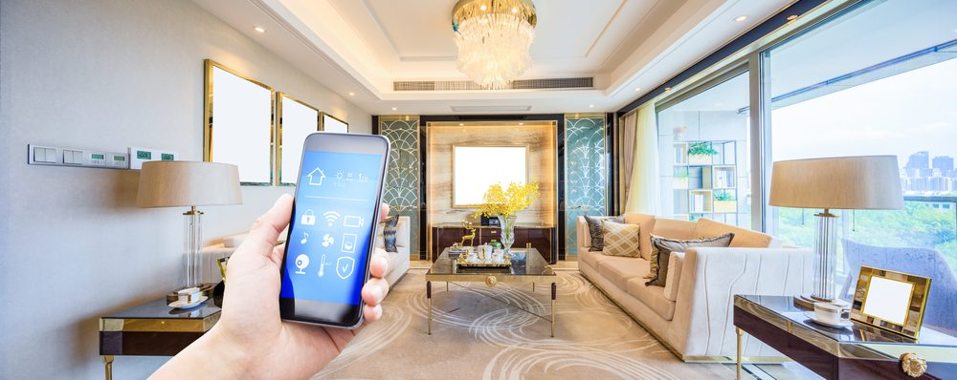

**Development of**

**Smart Home for the Lazy Man**

**(To Pass, Too Curious)**



1



**SCHOOL OF ENGINEERING**

Diploma in Electronics, Computer and Communications Engineering

**EG3371 – SMART CONNECTED SYSTEM PROJECT**

**Development of**

**Smart Home for the lazy man**

Lecturer:

**Ms. Lim Kwai Yoke**

Group name:

**To Pass, Too Curious (NYP Drift)**

Group members:

**Muhammad Hanafi Bin Mokhri (155893X)**

**Nasruddin Islam Bin Ramli (150841F)**

2

**Table of Contents**

1. Background…....…..…..…..…..…..…..…..…..…..…..…....…..…..…..…..…..….Page 4
2. System Architecture…....…..……...…..…..…..…..…..…....…..…..…..…..…..….Page 5
3. System Hardware…....…..…..…..…..…..…..…..…..…....…..…..…..…..…..…..…Page 6
4. System Software…....…..…..…..…..…..…..…..…..…....…..…..…..…..…..…..….Page 7
5. GUI Introduction…....…..…..…..…..…..……..…..…..…....…..…..…..…..…..….Page 11
6. System Setup…....…..…..…..…..…..…..…..…........…..…..…..…..…..…..…..…Page 12
7. Troubleshootings…..…..…..…..…..…..…..…..…..…....…..…..…..…..…..…..…Page 13
8. Appendix…....…..…..…..…..…..…..…..…..…..…..…....…..…..…..…..…..…….Page 15
9. References…....…..…..…..…..…..…..…..…..…..…..…....…..…..…..…..…...…..Page 16
10. Gantt Chart…....…..…..…..…..…..…..…..…..…......…..…..…..…..…..…..…..…Page 18

3

**Background**

Smart Home for the lazy man was developed for lazy people who are too busy to be busy or are just lazy. Simple things such as the unlocking of doors when you reach the door, closing of the windows when it rains or ensuring that you get off the bed before turning off the alarm are some of the things it does.

This project requires the development of a wireless sensor platform which controls the actuators using Wi-Fi and ZigBee. It consists of the following:

* Waspmote Receiver

-Consists of Sensor Board, ZigBee module, Wi-Fi module and sensors for pressure, light, water level, movement, speech and GSR.

-Information will be sent via ZigBee to Waspmote Coordinator.

* Waspmote Coordinator

-Uploads the sensor data for tracking to thingspeak using Wi-Fi.

4

**System Architecture**

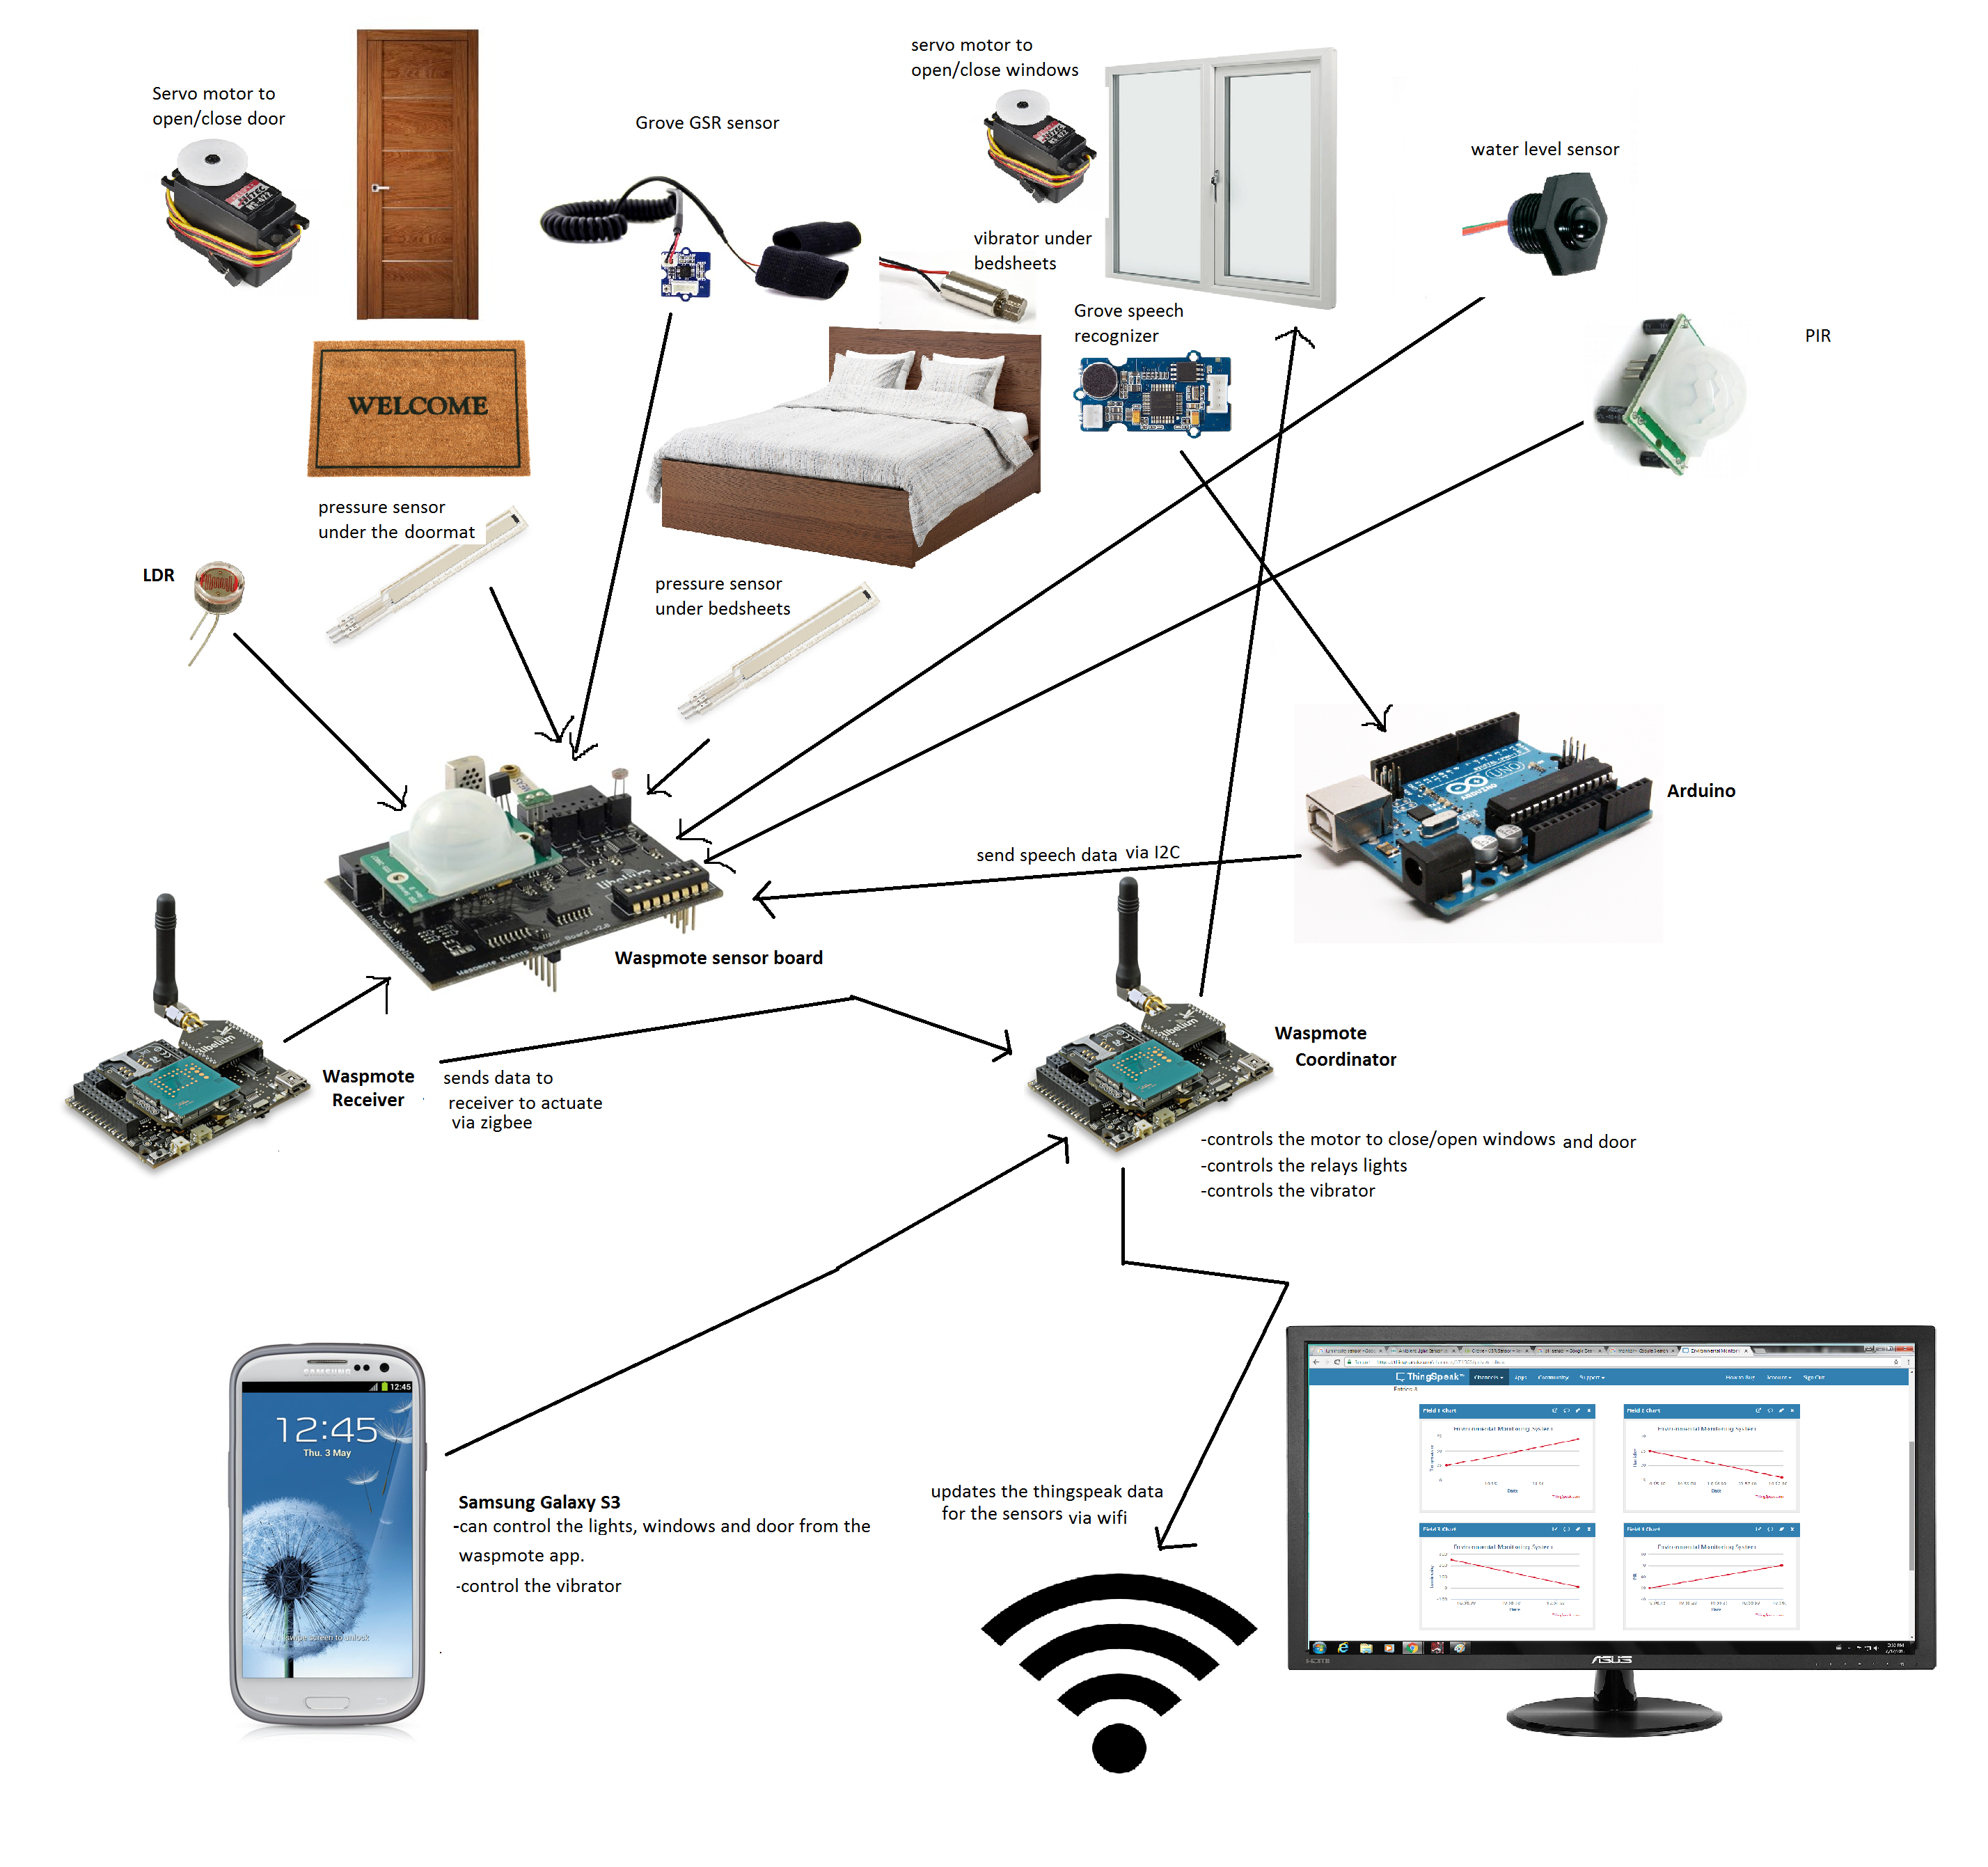

When it rains, the water level sensor on the sensor board detects the water and the receiver closes the window. Pressure sensor detects if there is someone on the bed and the receiver will trigger an alarm at a certain time unless the person gets off the bed. This same pressure sensor will cause the receiver to turn on the lights when the person gets off and if it’s dark. After opening the door, another pressure sensor will detect when the user steps on the mat inside the house and the door will close.

The door lock is controlled by the phone through Wi-Fi, once the owner’s phone is connected within a certain radius of the house.

The GSR sensor allows user to examine sleeping patterns, as well as working reading during waking up to the alarm.

The door can be unlocked by phone. The door, can also be controlled to open, and close on voice commands. PIR sensor senses burglars and suspicious individuals lurking outside your home and if it detects someone, the buzzer will activate and alert the owner via thingspeak.

5

**System Hardware**

**-Samsung Galaxy S3**

Controls the lamp, door lock and alarm.

-**Computer**

Stores and tracks information via thingspeak.

**-Waspmote board (Receiver)**

Collects sensor data and controls the door, door lock, windows, lights and buzzer.

Sends data to Waspmote Coordinator via ZigBee module.

**-Waspmote board (Coordinator)**

Receive data via ZigBee module.

Sends data to thingspeak via Wi-Fi module.

**-Arduino board**

Used for the grove speech recognizer.

**-ZigBee module**

**- Wi-Fi module**

**-Sensors**

-Light Dependent Resistor x1

-Grove Speech Recognizer x1

-Pressure Sensors x2

-Water level sensor x1

-PIR sensor x1

-Grove GSR sensor x1

**-Actuators**

-Servo motors x3

-Miniature vibrator x1

-Lamp and relay x1

-Buzzer and relay x1

6

**System Software**

-**Waspmote IDE**

This software is used for programming the ZigBee devices which includes ZigBee Coordinator, ZigBee Router and ZigBee End-Device with 3G module. It uses C++ language. It also enable you to do some modifications and uploads of examples of the coding provided.

**-ThingSpeak**

ThingSpeak is an open source Internet of Things application and API to store and retrieve data from things using the HTTP protocol over the Internet or via a Local Area Network. It is used to track the data of the sensors.

-**Visual Studio 2013**

For the Smart Parking System is programmed by Visual Studio 2013. It is also to ensure the Graphic User Interface (GUI) works by using the Visual Basic (VB) language.

7